Riverside Intermediate Orchestra

6th Grade Orchestra Handbook
2022-2023
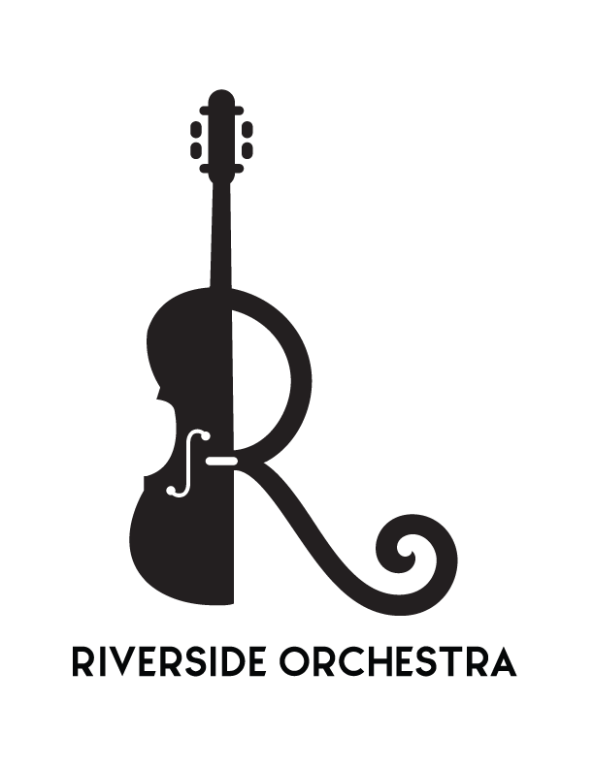

Mrs. Johanna Kitchell
jkitchell@hse.k12.in.us
(317)-915-4280 x6164
www.rjhorchestras.org
@mrskitchellrjh

Hello Students & Families – welcome to the Riverside Orchestra Program!

Are you so excited for this 2022-2023 school year!? I am thrilled you have chosen to learn a string instrument, and have chosen to carry on the tradition of musical excellence here at Riverside. Every player is a valued member of the orchestra; you have importance in the group. Orchestra is not like other classes; in here, your individual learning and growth has the added responsibility (and benefit) of contributing to your team’s success.

Here at Riverside, you are encouraged, and will have opportunities, to share your musical talents with other students, staff, and the community at large. This is one of the most rewarding parts of participating in an ensemble; bringing the music to those around you!

As the orchestra director here at Riverside, I am committed to providing a quality musical education for each and every student. Ensuring student success, however, requires a joint effort with teacher, student, AND parent/guardian. This handbook has been compiled to help you know my expectations and the expectations of each student. Topics discussed here include grading, classroom procedures, instruments, concerts, and more. Please take the time to familiarize yourself with its contents, and contact me with any questions or concerns.

Vision
Music education and music appreciation are vital elements to not only a school culture, but the greater society as a whole. Today’s adolescents are the musicians, and perhaps more importantly, the audiences, of tomorrow. Music allows a creative outlet for children, and develops teamwork, determination, problem-solving, social, and emotional skills. The Riverside Orchestra program strives to provide high-quality instruction, developing playing ability and nurturing the passion for music in all interested students.

Why Strings?
Participation in a school string instrument program enhances a child’s quality of life. It provides creative, emotional, and social opportunities, and unifies communities.
- Research on brain development has shown string players’ brains are larger, have more neural pathways, and process information faster.
- All children are capable of learning to play a string instrument, regardless of “talent” or musical background.
- The study of music has been demonstrated to complement other areas of academic study. In a recent survey, students with at least two years of study in the arts and music had significantly higher GPAs than students who did not.
- Music education programs enrich the whole student, and are a critical component to a well-round academic curriculum. Think STEAM, not STEM. Students in the arts demonstrate higher self-esteem and thinking skills than their counterparts.
- Unlike many other instruments, string instruments come in a variety of sizes, and adapt as students grow, allowing children of all sizes and ages to participate and learn.
- It’s fun! So much of the music in Western culture is built upon the basis of strings; from early orchestral music, to the treasured history of composers like Mozart and Beethoven, to the string instruments often used in country, pop, and rock today.
2022-2023 Calendar of Events

Date | Concert | Time | Orchestras
Thursday, December 15th | Beginning Winter Concert  (RSI Gym) | 7:00pm | 6th Grade, Beginning JH
Tuesday, May 23rd | Beginning Spring Concert  (RSI Gym) | 7:00pm | 6th Grade, Beginning JH

Concert Expectations

You have chosen to join a group of students working every day towards a common goal. These concerts are the culmination of our efforts, and are a vital part of the educational experience. There is no amount of make-up work, or alternative assignment, that can replicate the unique experience of a performance. By helping to maintain a standard for etiquette and attendance at performances, you are ensuring the quality of the orchestra program and learning the value of the performing arts in adolescent development.

Concert attendance is MANDATORY the two 6th grade concerts; all students are expected to perform.

Exceptions will only be made in cases of severe illness or family hardship (death, emergency, etc). Extra-curricular sports and clubs are not excused absences. Orchestra is a co-curricular, graded class; the commitments to coursework take precedence over extra-curriculars. As a coach and athlete myself, I understand the importance of sports and other activities; communicating with me allows me to discuss potential conflicts with coaches. There is always a way to make it work; I am flexible to the best of my ability!

Concert Dress
Our concert dress is as follows:
- Riverside Orchestra shirt
- Black dress bottoms (pants or skirts)
  - Skirts must fit in the Riverside dress code (length)
  - No jeans, no leggings, no athletic pants, no sweatpants
- Black dress shoes
  - Boys need to wear long black socks
  - No sneakers, no slippers, no flip flops or other casual shoes
- There should be no large visible stripes, dots, or logos on any concert clothing
- Cellists who choose to wear skirts must wear one longer than their knees
- Students may wear a tie, bowtie, or suspenders, if they are garnet, gold, black, or white
- Students may wear their hair as they choose

You can order a shirt using the Envelope Order Form – please return to Mrs. Kitchell by Friday, August 26th. If you would like a “refurbished” shirt, instead of a new one, indicate so on the form. Refurbished shirts are $5 and subject to supply; Mrs. Kitchell will confirm via email.
Classroom Expectations

Items Required for Class Daily:
- Instrument
  - Violins & violas go back and forth (don’t forget shoulder rests)
  - Cellos & basses are provided for student use in class
- Essential Elements for Strings, Book 1
  - If you have rented an instrument from Paige’s Music, this book has been provided with your rental. If you have not rented from Paige’s, you will need to order a book. Use the envelope order form; orders are due by Friday, August 26th.
- Music folder, with current concert music (this will come later)
- A positive attitude, and a willingness to learn, focus, and contribute

Prohibited Items:
- Gum
- Cell Phones
- Food/Drink

Classroom Procedures:
- When you leave your classroom, check the whiteboard in the hallway as you walk down. This will have your room assignment for the day. Please read it carefully and find your instrument & room. It may change each day.
- Class starts at 3:20. That gives you 10 minutes to get your instrument and backpack, WALK to your room, and unpack. By that time, you should be at your stand, with your instrument out and ready to play, or in line to be tuned. Arriving to class late or not being ready at your stand counts as a tardy.
- While the teacher is tuning, you are not socializing. You are in line to be tuned, or at your stand, silently practicing. Your teacher will tell you what to be working on.
- When the teacher is in front of the group, the class is quiet. You may talk freely only when you have been given permission.
- There is no extra plucking or playing during class. When the teacher is talking, or working with another section, you should sit quietly. Calling out is not allowed as well – please raise your hand to speak.
- If it is not yours, don’t touch it! This includes other instruments and supplies in the room. You are not to touch, move, carry, or switch instruments in any locker areas.
- All equipment should be put away carefully at the end of class. Be sure to loosen your bow and properly close your case. Take all materials with you and put them away properly.

Practicing Expectations

- You cannot improve if you don’t practice! 6th Grade Orchestra students should expect to practice at least one hour a week. That may seem like a lot, but if you practice 10 minutes a day, it amounts to over one hour each week.
- Over the course of the year, we will learn how to practice. Sounds silly, but really, learning what to do on your own is a process! 6th Grade Orchestra students will have Practice Assignments throughout the year to help guide their practice sessions. These may be written or playing assignments, and will be distributed via Canvas or on paper.
- Each week, I will post “This Week in Orchestra” on Canvas. This should be referenced to help you know what we are working on in class, and what to practice at home!
- Orchestra is a year-long commitment. Learning anything new takes time, and can be very difficult at times. The expectation at Riverside is that students remain in orchestra for the duration of the school year.

Grading Procedures

In order to succeed in orchestra, students should demonstrate two things: a willingness to improve their skills, and a musical work ethic that will contribute to the team. It would not be fair to assess a student’s progress based solely on playing abilities. I do not grade on talent.

Students in orchestra are expected to:
- Show an improvement in overall performance skills over the course of the year
- Be on time and prepared to class
- Be respectful of other people, equipment, and facilities
- Show a positive attitude toward teachers and other students
- Complete all playing and written assignments (practice cards)
- Demonstrate a willingness to accept comments designed to help
Based on these expectations, grades are based on a combination of:
- Daily in-class preparation and behavior (see below)
- In-class written or playing assignments (varied; short quizzes on note names, etc)
- Practice Assignments (semi-weekly/frequent basis)
- Concert attendance and etiquette

All students begin the quarter with 100 points for class preparation and behavior; failure to follow expectations and policies results in a deduction, 1 point per instance. Continuous days with preparation/behavior infractions will result in additional consequences, including calls home or referrals. Practice cards are worth 10 points each. Concerts are worth 50 points each.

ASSISTANT TEACHERS DESERVE THE SAME RESPECT AS ME. THEY HAVE PERMISSION TO CORRECT BEHAVIOR AND/OR MARK GRADES. They will also report behavior issues to me.
- Assistant teachers will have a gradebook sheet for each group of instruments. They will be monitoring behavior and preparedness. Students who are disruptive or disrespectful, or who come unprepared for class, will be noted by the assistant teacher. This will be reported to me on a daily basis.

Late practice assignments are accepted until the end of the quarter, but not after that.

Students may earn extra credit by attending live music – classical, professional concerts and performances, or any other HSE School performance. You can earn the credit by turning in a program or ticket (or a photo of you there).
Families, if you have a concern about grades or assignments, I encourage you to speak your child first, before reaching out to me. Students, your grade - and your success - is YOUR responsibility. Take ownership of your learning, both with me in class, and with your family at home.

Instruments

Take care of your instrument – it is a fragile and expensive piece of equipment!
- School cellos and basses are the property of Riverside. Any damage will be assessed; students may be held accountable for repairs, if it was deemed purposeful.
- Home cellos and basses can be brought in for tuning at any time.
  - Drop them off in the main office, and be sure to notify me; I will tune them within one school day.
  - If transportation is an issue; reach out to me. I will make a house call for tuning.
- Violins and violas should be carefully transported back and forth each day.
- Students who forget their instrument at home will be provide a loaner for use in class. This will be counted as unprepared, but you will not be deprived of the learning that day.
- If you rent from Paige’s, you can take advantage of their Tuesday school visit. Contact them by Monday night with any needs (repairs, size changes, accessories and supplies); these will be delivered mid-day Tuesday.

Learning Environment

Each one of us is responsible for cultivating the learning environment in orchestra. We will keep the following in mind:
- We are a team. Every person is a valid member of our orchestra.
- We respect each other. Mutual respect is expected among all members of the group.
- We try our best. Best effort is expected during each rehearsal, concert, and event.
- We learn from our mistakes. We see our mistakes as opportunities to learn and grow.
- We celebrate each others’ successes. We will celebrate our successes, both individually and as a team.
- We are here to create music. Our primary purpose in orchestra is to make music, together.
Adhering to these principles will ensure a safe and respectful environment for everyone.

Communication

There are a few ways to keep in touch and up-to-date with the Riverside Orchestra program:
- Canvas – all students are automatically enrolled, parents may choose to “observe.” Assignments, announcements, and calendar items will all be updated here.
- Email – I will send emails on occasion – make sure your address is correct in Skyward!

***A note of information – right now, I have all student bows. We learn to play with just the instrument first, and then we add the bow later. Bows are labeled by student, and are safely locked up. Thank you for understanding my educational process.***
Student-Family-Teacher Agreement
Return this to Mrs. Kitchell by Friday, August 26th, 2022

Student First/Last Name _____________________________________ Nickname? ______________

Family Member #1 (Parent/Guardian) Name _________________________________
Cell or Home Number _____________________________
Email _______________________________________________
Preferred Method of Contact (circle) phone email

[optional] Family Member #2 (Parent/Guardian) Name _________________________________
Cell or Home Number _____________________________
Email _______________________________________________
Preferred Method of Contact (circle) phone email

Do You Take Private Lessons? yes no If Yes, With Whom? ___________________________

Other activities and interests ___________________________________________________________

What else do you want me to know about you? __________________________________________
_____________________________________________________________________________________

Student Guardian (please initial on the lines below)
_______ _______ We have noted the mandatory concert dates listed here for this school year, and understand that they are a graded component of orchestra class.

_______ _______ We have read the daily classroom expectations, and understand what is needed to be prepared in class each day.

_______ _______ We have read and understand the concert dress requirements.

_______ _______ We have read and understand the practice expectations for orchestra, and will do our best to achieve the practicing required.

_______ _______ We understand what it means to be a contributing and supportive member of the orchestra team.

Guardian Only _______ My child may have the occasional snack or piece of candy in class.
Please list any allergies _______________________________________

Student Signature___________________________________________ Date ______________
Parent/Guardian Signature___________________________________ Date ______________

